Predict Waste Quantity Tonnes per Year
Waste Management in the Republic of Ireland
Dataset used: EPA Licensee Waste Data, 2021 to 2024

Contents
Executive summary 2
1. Introduction and aim 3
2. Business understanding and project framework 3
3. Data collection, structure and data quality 4
4. Descriptive statistics and exploratory data analysis 6
5. Statistical analysis with Binomial, Poisson and Normal distributions 9
6. Data preparation for machine learning and visual design 11
7. Machine learning models, tuning and evaluation 13
8. Discussion, practical implications, limitations and conclusion 14
Appendix A. Additional notebook figures 16
References 17

Executive summary
This report studies waste management data for the Republic of Ireland from 2021 to 2024. The work uses four EPA licensee waste files, which were already combined in Python. The selected problem is to predict Waste Quantity (Tonnes per Year). This provides a straightforward supervised regression assignment. It is also suitable for the assignment since the target is a number and can be used to plan.
The merged dataset has 31,028 rows and 16 columns. It includes four years of records. The initial check revealed 13 duplicate rows and no empty rows. A number of columns had missing values. But the missingness was not uniform. A lot of it was structural. There are areas applicable to a single step in waste movement. That is important since thoughtless imputation would yield poor outcomes.
Exploratory data analysis showed a highly skewed target. The average was 2,403.90 tonnes, and the median was just 53.4 tonnes. The maximum was 1,499,662 tonnes. This indicates a few huge records. A log transform made the target much easier to model. The annual total tonnage appeared quite steady over the four years, with slight declines in 2022 and 2023 and an increase in 2024.
Binomial, Poisson and Normal distributions are also used in the report. The Binomial component considered the final destination abroad. The Poisson component accounted for the number of records finally treated per licence-year. The normal part considered the quantity of log waste. These options are suitable for both the assignment and the data types. The findings indicated that discrete variables could be used to provide simple explanations of probability, whereas the log-transformed continuous target variable was significantly more normal.
CRISP-DM was the optimal project framework for machine learning. It is suitable for this task since the work begins with a practical question, proceeds to data comprehension and preparation, and concludes with model assessment and business application. A supervised learning approach was selected because the training rows are known to have the target value. Two tree-based regression models were run using GridSearchCV. These were the Decision Tree Regressor and the Random Forest Regressor.
The Random Forest model produced better results. Its MAE was 2160.82 tonnes. Its RMSE was 24997.22 tonnes. Its R² was 0.247. The Decision Tree had weaker scores on all three metrics. Nevertheless, the skew of the target was heavy in both models, and they were also constrained by the absence of context variables. The last opinion is that the project is legitimate, the analysis is sound, and the best model to apply to this data is the Random Forest.
Table 1. Dataset overview
Item | Value
Merged rows | 31,028
Columns | 16
Years covered | 2021 to 2024
Duplicate rows | 13
Fully empty rows | 0
Rows with target | 18,088
Training rows | 14,470
Test rows | 3,618

1. Introduction and aim
Waste management is a good area for data analytics. It is volumetric, movable, treated and reported. It also contains numerous practical questions. Governmental institutions and licensed facilities must be aware of what is happening. They must also have a rough idea of future pressure. Irish waste statistics, according to the EPA, are intended to be reported, planned, and used in policy (EPA, 2026). That renders this subject applicable and practical.
The uploaded files contain EPA licensee waste data for 2021, 2022, 2023, and 2024. The broader context of the scenario also included Eurostat and other Irish sources of information (Eurostat, 2026). However, this report relies on the provided EPA files and the Python notebook used to run it. Python in Jupyter Notebook was used to generate all the analysis and visuals as needed.
The area of interest selected is the amount of waste in licensed sites. The main project question is simple. Is it possible to predict annual waste tonnage based on the waste attributes recorded? The specific measure is Waste Quantity (Tonnes per Year). It is a good target since it is continuous, measurable and directly connected to planning. The larger tonnage can indicate increased transport requirements, increased treatment pressure, or increased storage pressure.
There could be other types of tasks. A classification problem might have been constructed as well. For example, a project could classify whether a record is high tonnage or low tonnage. But that would take the detail out of the actual amount. For this reason, regression was kept. It is more aligned with the target. It also provides a better test of model quality, since the prediction error can be measured in tonnes.
It is not the purpose of the report to demonstrate a model. The objective is also to legitimise the decisions. The task requires statistics, EDA, data preparation, visualisation design and machine learning. This report is structured in such a manner. It demonstrates what has been done, why it has been done, what the notebook discovered, and the boundaries.

2. Business understanding and project framework
CRISP-DM is the most suitable framework for this project. It begins with business understanding, followed by data understanding, data preparation, modelling, evaluation, and deployment thinking. This order is quite appropriate for this waste study (IBM, 2026). The work starts with a practical question regarding tonnage. The dataset is then checked. Then the information is made ready. This is followed by testing of the models. The final product can be discussed in a planning context. So the steps are easy to follow.
Other frameworks are KDD and SEMMA. But they are not so applicable here. KDD is strong in knowledge discovery and seems more technical, with less emphasis on the business loop. SEMMA can be used to model work, although it comes later in the process. It is not as useful when the project has to justify the problem at the outset. This task requires a complete story between problem choice and evaluation. CRISP-DM does that.
This is illustrated by a real-life waste planning example. A question may be posed by a local authority or regulator. What are the largest future tonnages of waste streams recorded? That is not just a question of modelling. It is also concerned with the business requirement, the source of data, the quality of data and whether the outcome is satisfactory to take action. CRISP-DM is in favour of that complete path. This is why it was chosen.
The machine learning option is supervised learning. This is due to a direct cause. The target value is already present in the modelling rows. The model is trained on rows with known waste tonnage and predicts tonnage for unseen rows. Clustering of similar waste streams or facilities would be more appropriate in unsupervised learning. The modelling subset yields many labelled rows, so semi-supervised learning is not required.
Two regression models with supervision were selected. These were the Decision Tree Regressor and Random Forest Regressor. They are both common scikit-learn nonlinear regression models (scikit-learn developers, 2026). They are compatible with mixed data types with minimal preparation. They can also be explained easily. That counts in a student report. A more sophisticated model was not applied to the project as the short values are clear-cut decisions and critical analysis, not complexity itself.

3. Data collection, structure and data quality
These were four EPA CSV files, one for each year from 2021 to 2024. They were combined into a single dataset in Python. The merged shape was 31,028 rows and 16 columns. The extra column File Year was added during the merge. The old Reporting Year field was also maintained. This proved useful, as it maintained the value of the source file year and the reporting year within the data.
The dataset consists of licence profile, waste source, waste action, waste codes, types of treatment, destination fields, accepted quantity fields, and annual waste quantity target. This implies that it is not just a file at a single step in the waste flow. It has accepted waste, transferred waste, and, lastly, treated waste. That helps, but it also leaves many missing values because not all fields are applicable to all stages.
The initial quality control was simple yet significant. There were 13 duplicate rows. That is tiny in comparison to the entire dataset. No completely empty rows. Thus, the file was not plagued by large blank rows. It was a good omen. The larger problem was the lack of values by column. The poorest field was Next Destination Waste Treatment Type with 82.32% missing. There were also several other treatment and destination columns with over half missing.
This appears to be bad data quality at first glance. But a more careful examination altered this opinion. The three accepted quantity columns had no non-missing values when rows containing a valid target were isolated. This is not a chance missingness. It is structural missingness. Those columns describe accepted waste. The modelling subset is mostly used to describe transferred or ultimately treated waste. The percentages of records in the target rows with Waste Action of Transferred and Finally Treated were 95.03% and 4.96%, respectively. Waste Accepted was only in one row. So the accepted quantity fields were not relevant for the final modelling subset.
This discovery is significant. When the report considered these blanks as random and just filled them in, the data story would be poor. It is preferable to state the reasons for the blanks. Before modelling, it is also preferable to eliminate such columns. That is what the notebook did. This was a right action. It brought the preparation step closer to the truth and closer to the meaning of the fields.
The target itself was in 18,088 rows. That comprises 58.3% of the entire merged data. This is still a large modelling sample. Suffices for descriptive work and two supervised models. Thus, missingness was high in certain locations, but the dataset was not too sparse to perform the selected task.
Table 2. Highest missingness columns
Column | Missing Count | Missing % | Data Type
Next Destination Waste Treatment Type | 25541 | 82.32 | object
Final Destination Waste Treatment Type | 18491 | 59.59 | object
Accepted Waste Quantity | 18089 | 58.30 | float64
Accepted waste quantity from abroad | 18089 | 58.30 | float64
Accepted Waste Quantity from Ireland | 18089 | 58.30 | float64
Final Destination Abroad | 17765 | 57.25 | object
On Site Waste Treatment Type | 17191 | 55.40 | object
Waste Quantity Tonnes per Year | 12940 | 41.70 | float64

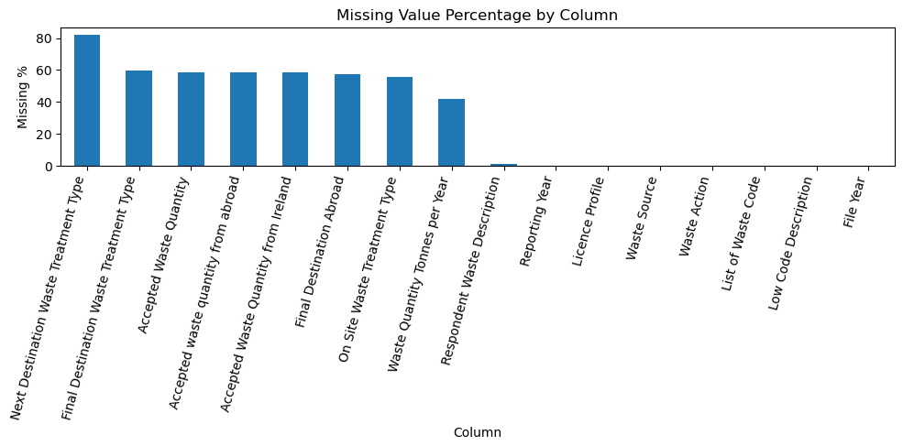
Figure 1. Missing value percentage by column. Source: executed notebook output.

4. Descriptive statistics and exploratory data analysis
The first picture was very clear with the descriptive statistics. The mean and standard deviation of Waste Quantity tonnes/year were 2,403.90 tonnes and 22,694.27 tonnes, respectively. The minimum was 0. The first quartile was 8. The median was 53.4. The third quartile was 376.79. The maximum was 1,499,662. This is an enormous dispersion. The median is much lower than the mean. That is highly skewed to the right.
This was confirmed by the raw histogram. The majority of the records were minute. A few were extremely large. The skewness was 36.17. That is very high. And that is why the target is not a normal variable in its raw form. This is important both in statistical interpretation and machine learning. Averages and model errors can be dominated by large outliers. They can also render plots difficult to read. This is the reason why the notebook modelled the target with a log transform.
The log histogram was much improved. The values were not ideal yet, but the shape was more balanced. This made the subsequent normality test more reasonable. It also enhanced the stability of model training. The report considers this as one of the most significant preparation decisions in the project.
The annual total plot revealed that the recorded tonnage remained widely constant over the four years. The totals were about 11.00 million tonnes in 2021, 10.79 million in 2022, 10.62 million in 2023 and 11.08 million in 2024. Thus, there was no dramatic break during the short period. There was a slight fall and then a rise again. This type of outcome is important. It implies that there is a change in the short term on an annual basis, but not very high in the sample.
The highest category chart also provided valuable information. The greatest group was, by far, soil and stones, other than those in 17 05 03. The period was approximately 14.73 million tonnes. Other mechanical treatment wastes were the next largest, at approximately 6.90 million tonnes. Next was municipal mixed residual household waste, amounting to approximately 3.42 million tonnes. This indicates that a few waste streams account for a large proportion of the tonnage.
There were various reasons why EDA was employed. It verifies the data form. It checked possible outliers. It exhibited category concentration. And it assisted in the subsequent design of models. Illustrations were not ornamental. They all responded to a question. This is based on the simple principle that a good chart must present data in an uncluttered, easy-to-understand format (Tufte, 2001). The reason was that the charts in this report were simple bar, line, and histogram plots.
Table 3. Descriptive statistics for Waste Quantity Tonnes per Year
Statistic | Value
count | 18,088.00
mean | 2,403.90
std | 22,694.27
min | 0.00
25% | 8.00
50% | 53.40
75% | 376.79
max | 1,499,662.00

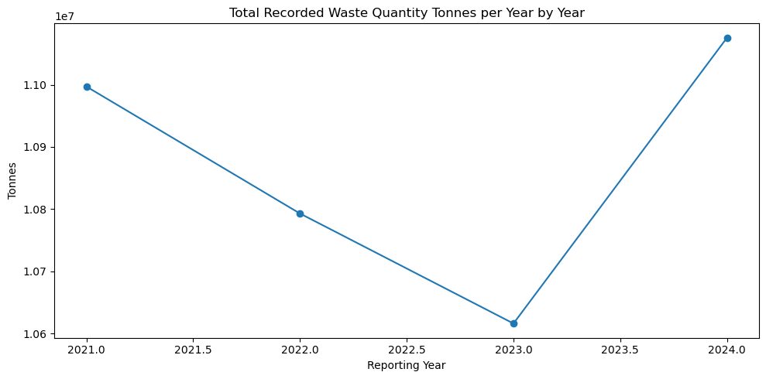
Figure 2. Total recorded waste quantity tonnes per year by year. Source: executed notebook output.

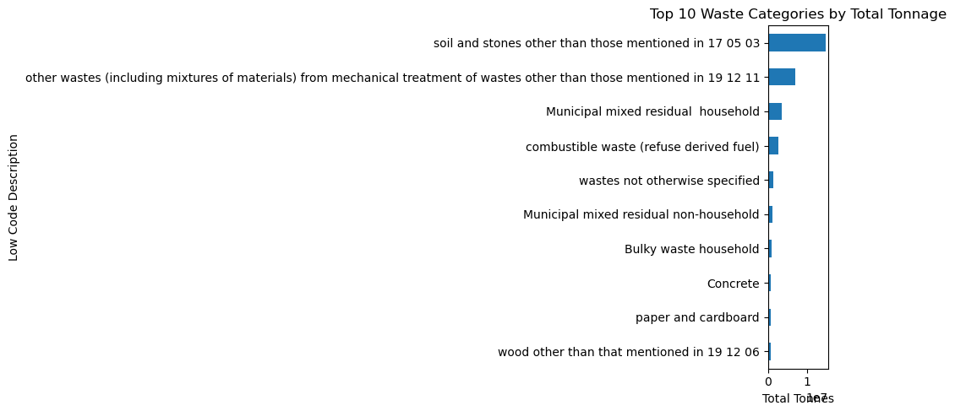
Figure 3. Top 10 waste categories by total tonnage. Source: executed notebook output.
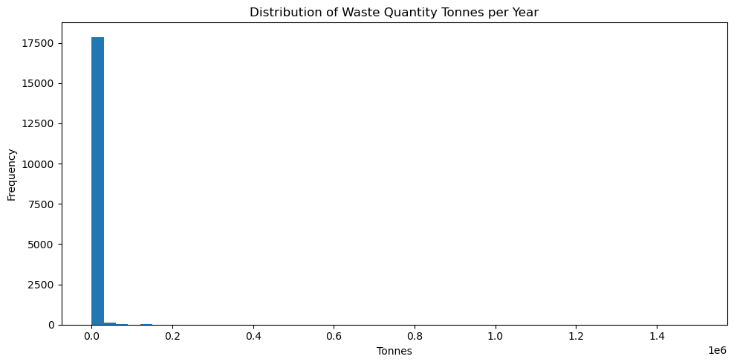
Figure 4. Distribution of Waste Quantity Tonnes per Year. Source: executed notebook output.
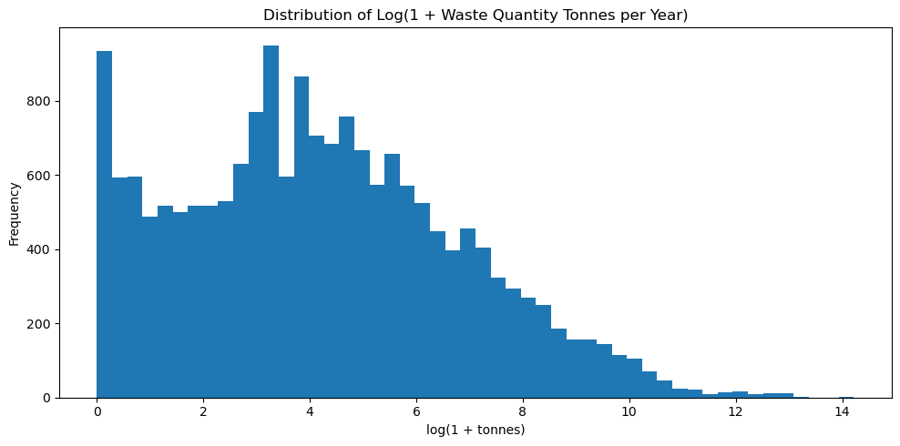
Figure 5. Distribution of log transformed waste quantity. Source: executed notebook output.

5. Statistical analysis with Binomial, Poisson and Normal distributions
The task required Binomial, Poisson and Normal distributions. Each had one sensible variable in the notebook. This choice is important because each distribution applies to a different type of data.
The Binomial distribution was used for a binary event. The question was whether the ultimate destination was overseas. The rows with non-missing Final Destination Abroad values were retained. This gave 13,263 records. The probability of an overseas destination was estimated to be 0.5136. That is, the rate of occurrence was nearly half. This simplified the Binomial example to explain. The likelihood of 60 being abroad was 0.018012 with 100 records. The probability of at least 60 being abroad was 0.051319.
This is a valid Binomial structure because the event is yes-or-no. A Binomial variable is the number of successes in a given number of trials. In this case, abroad is yes. The n = 100 chart was relatively symmetric as the probability is close to 0.5. The additional chart with n = 300 demonstrated a large-sample effect. The Binomial distribution becomes smoother and more bell-shaped as the sample size increases. To explain this is handy. It demonstrates how large samples can cause a discrete distribution to appear more like a Normal distribution.
Final records of treated counts per licence-year were counted using the Poisson distribution. This is a reasonable option as well. Poisson is used in count data, particularly when counts occur on a fixed exposure. In this instance, one licence in one year is the unit. The average number, or lambda, was 3.8584. The number of observations was 233 licence-years. The observed variance was 29.5704, which is significantly higher than the mean. This is important. The variance and the mean ought to be near in a basic Poisson pattern. This was not the case here.
There were two applications of the Poisson section. First, it provided a correct example of a count-based probability. Second, it demonstrated a weakness. There was overdispersion in the observed data. This implies that the counts are not varying as a simple Poisson model would. This was indicated in the chart, as the histogram's spread was broader than the fitted Poisson line. This is good critical analysis. The report does not impose an ideal fit where none exists. The Poisson chart with a large mean (mu = 25) also illustrated the sample-size concept. With an increasing mean, the shape of the Poisson distribution becomes more symmetric and closer to a Normal distribution.
The target was log-transformed and distributed according to the Normal distribution. This was the right place to use it. The amount of raw waste was too imbalanced. But log(1 + waste quantity) was much closer to a bell shape. The average of the log target was 4.1961, and the standard deviation was 2.6036. The proportion of the observations that fell within one standard deviation of the mean was 0.6374. An ideal distribution of Normality would provide approximately 0.68. The fit was not precise, then, but it was close enough to be useful as an explanation.
This section must also include a statement of why these distributions are important. The Binomial distribution is important because it describes a yes-or-no process in the data. The Poisson distribution is important as it describes count processes. The importance of the Normal distribution is that many modelling concepts and summaries are simplified when a variable is approximately symmetric. In this project, the log transform brought the target nearer to such a shape. That assisted in understanding and modelling.
The Binomial and Poisson discrete variables cannot be treated as Normal distributions. The flag abroad is two-fold. It can only be approximated by a normal distribution when the sample is large. The end-treated count is a non-negative count. It may also appear more Normal with a large mean. But in small or disproportionate samples, that would be a feeble assumption. So the report first presents the discrete variables in discrete terms. That is the more secure option. The only shapes that are used to explain why the Normal approximations may be seen later are the large-sample shapes.
Table 4. Key distribution results
Measure | Value
Estimated probability of final destination abroad | 0.5136
Records used in Binomial section | 13,263.0
Probability of exactly 60 abroad out of 100 | 0.0180
Probability of at least 60 abroad out of 100 | 0.0513
Poisson lambda estimate | 3.8584
Observed Poisson variance | 29.5704
Mean of log target | 4.1961
Standard deviation of log target | 2.6036
Share within 1 SD of mean | 0.6374

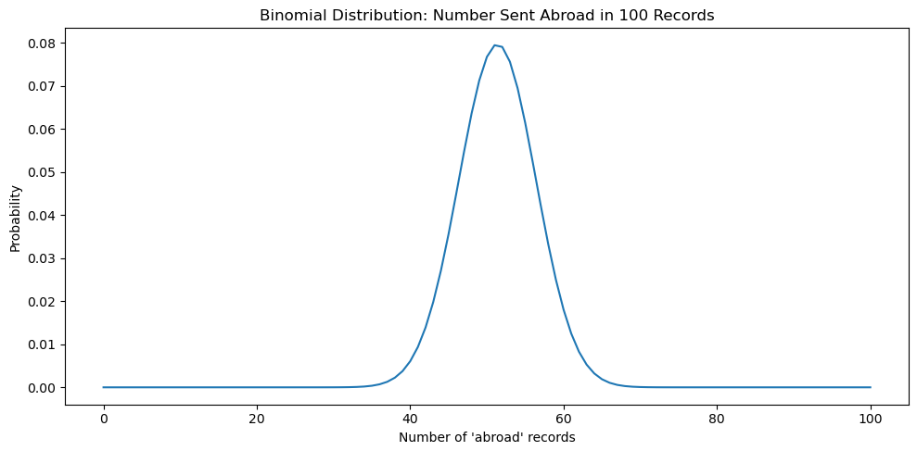
Figure 6. Binomial distribution for number of records sent abroad in a sample of 100. Source: executed notebook output.
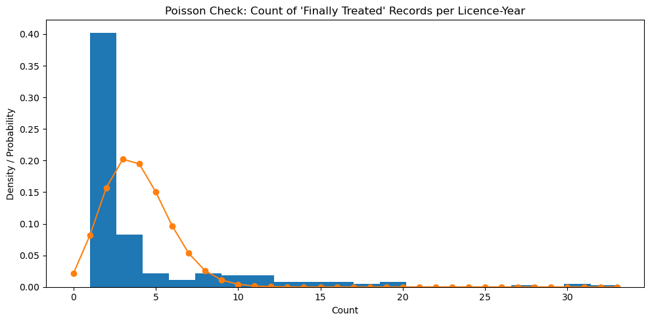
Figure 7. Poisson check for counts of Finally Treated records per licence-year. Source: executed notebook output.
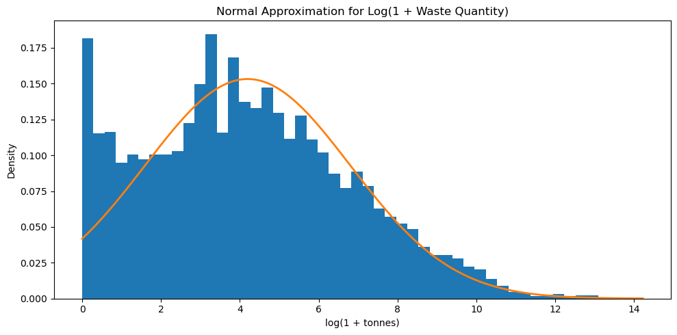
Figure 8. Normal approximation for the log transformed target. Source: executed notebook output.

6. Data preparation for machine learning and visual design
The notebook was based on a basic preparation pipeline. This was a good decision. It was not a fancy code that was required in the assignment, but a justification. The modelling subset retained the rows with the target. This left 18,088 rows. There were nine input variables then. The reporting year was a single numeric variable. The remaining eight were categorical, such as Licence Profile, Waste Action, waste code, description, type of treatment, and destination.
Prior to modelling, three columns had been taken out. These were Accepted Waste Quantity, Accepted Waste Quantity abroad and Accepted Waste Quantity Ireland. The explanation was quite simple. Those were structurally empty fields in the modelling subdivision. It would be noisy to keep them. It would also weaken the story of preparation. The description of the respondent was also not included. There was spelling variation and noise in the free-text style in that field. The category was already better represented by Low Code Description.
For missing values, the notebook used median imputation for numeric data and a constant value of 'Missing' for categorical data. Only the Reporting Year was numeric, and therefore, median imputation was not detrimental. The nominal fields contained actual blanks, and a Missing label was used to maintain this data. This can be more effective than losing big chunks of data.
For encoding, OrdinalEncoder was used in the notebook. This converted the text categories to numeric values of the models. The encoder also handled unknown values safely during testing. When scaling, the notebook did nothing. This was accurate because tree-based models do not need to scale features as distance-based or linear models often do (scikit-learn developers, 2026).
The split was 80% for training and 20% for testing. This provided 14,470 rows for training and 3,618 for testing. That is a reasonable division. It provided sufficient information to train on, and it retained a large hidden test set to test. The hyperparameter optimisation was performed using GridSearchCV. This is also an option, as it searches within a specific grid and provides a fairer comparison of the model (scikit-learn developers, 2026).
The visual design must also be warranted. The plain matplotlib charts with direct titles and labels were used in the notebook. This would be suitable for clearly demonstrating data, with no chart junk, as described by Tufte (2001). The graphs were not overloaded with heavy colours, 3D effects, and additional decoration. Category comparisons were done using bar charts. The yearly trend was plotted using a line chart. Distributions were done using the histograms. This is appropriate since each chart type was suited to the question it was intended to address.
Table 5. Data preparation choices
Preparation step | Decision used
Modelling subset | Keep only rows with target value
Dropped columns | Remove three accepted quantity columns
Free-text handling | Do not use Respondent Waste Description
Numeric imputation | Median
Categorical imputation | Constant label: Missing
Encoding | OrdinalEncoder
Scaling | No scaling for tree models
Train-test split | 80% train and 20% test

7. Machine learning models, tuning and evaluation
Two regression models were used in the project. The initial one was a Decision Tree Regressor. The second one was a Random Forest Regressor. They were both installed into a pipeline and preprocessed in the same way. This is a good practice as the preparation is maintained uniformly among models. It also renders the comparison equal.
The Decision Tree was dialled on max depth of 10, 20, 30, and none, and min samples per leaf of 1, 3, 5, and 10. Maximum depth = 20 and minimum samples per leaf = 10 gave the best tree settings. This implies that a certain measure of control on the size of trees was helpful. An extremely loose tree would have an overfit to the training data. The selected minimum leaf size is to minimise that risk.
Random Forest was adjusted to n_estimators of 100 and 150, max_depth of 10, 20 and None, and min samples leaf of 1, 2 and 5. The optimal parameters were 150 trees, max depth = 20, and min samples leaf = 2. This makes sense. The model boasts a large number of trees and maintains some control over leaf size.
The evaluation used MAE, RMSE and R². This is a powerful regression set of metrics. MAE indicates the mean error in tonnes. Big errors are given more weight in RMSE. This is necessary in this case since the target has extreme values. R 2 indicates the extent of the variation accounted for by the model.
The Random Forest was better on all three metrics. Its MAE was 2160.82 tonnes. Its RMSE was 24997.22 tonnes. Its R² was 0.247. The Decision Tree had an MAE of 2381.77 tonnes, an RMSE of 26403.00 tonnes, and an R² of 0.160. So the forest minimised bias error, and it also described more variance.
This was easy to read in the bar chart, but the large RMSE values make the R2 bars very small on the same graph. One of the little weaknesses of the comparison chart is that. Nevertheless, it depicts the general trend. The sample prediction table is also beneficial. It demonstrates that both models had some extremely large real values. To illustrate, when the actual tonnage was very large, the two models tended to yield very low values. This is no wonder. Only four years of data and a small number of features make it difficult to learn about extreme values.
Thus, the modelling outcome is ambivalent. The Random Forest is better. But the performance is still modest. A value of about 0.25 on the R 2 indicates that a larger percentage of the variation remains to be explained. This does not render the model useless. It merely implies that the dataset has boundaries. The observed characteristics are useful, but they do not give the complete picture. Not included here are site capacity, local policy, economic activity and wider trends in waste generation..
Table 6. Tuned model comparison
Model | Best settings | MAE | RMSE | R²
Decision Tree Regressor | max_depth = 20, min_samples_leaf = 10 | 2,381.77 | 26,403.00 | 0.160
Random Forest Regressor | n_estimators = 150, max_depth = 20, min_samples_leaf = 2 | 2,160.82 | 24,997.22 | 0.247

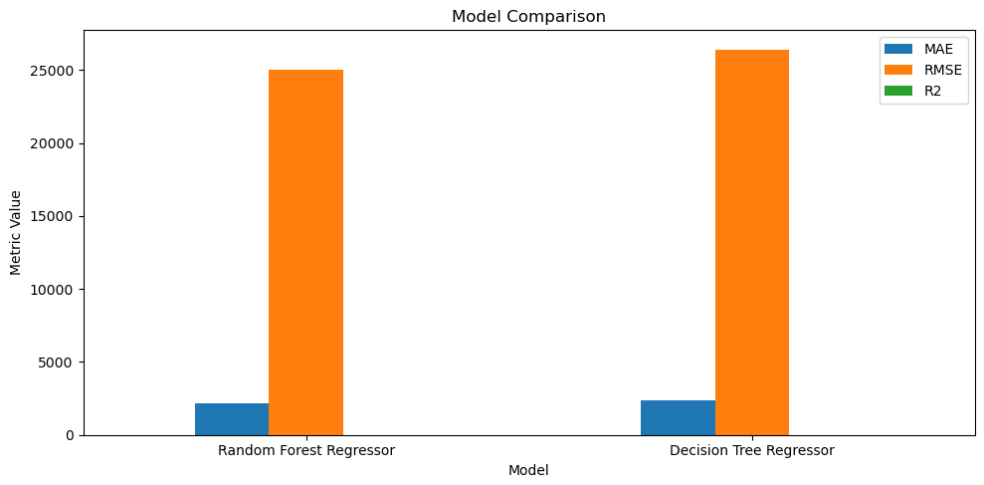
Figure 9. Model comparison chart. Source: executed notebook output.
Table 7. Example of actual and predicted values
Actual Tonnes | Decision Tree Prediction | Random Forest Prediction
2.520 | 3.783 | 4.377
32.083 | 61.411 | 52.694
1,184.989 | 274.642 | 266.396
1.500 | 2.146 | 1.763
2,126.900 | 461.940 | 433.832
1,427.740 | 5,459.567 | 3,774.619

8. Discussion, practical implications, limitations and conclusion
There is one obvious similarity between the two models. Both are tree-based. Both can handle nonlinear patterns. Both can take mixed inputs after basic encoding. They are also both simple to describe at the simplest level. This qualified them to undertake this assignment.
The distinction is that the Decision Tree trains a single set of splits, whereas the Random Forest trains multiple trees. The reason is that the forest tends to be more stable. The same trend could be observed here. The single tree was easier to interpret, though it performed poorly in tests. Random Forest achieved a lower error and a higher R. That implies that the data has interactions, irregularity, and is better represented by an ensemble.
The work has some practical applications. It is possible to predict the amount of waste per year to aid planning. It can be used to alert to records that may result in heavy treatment loads. It can aid rough capacity assessment during the transfer or treatment phases. It may also be used to demonstrate the waste streams associated with higher amounts. All this is not to be considered as precise forecasting. Yet it can aid timely decision-making.
Limits are also clear. The statistics are limited to four years. Some areas are lacking due to the process structure. The target is very skewed. And the model learns only from the fields recorded in the file. It is unaware of broader drivers beyond the data. That involves weather, construction cycles, business activity, local waste policy, or last-minute operational changes.
In general, the project is compliant with the assignment requirements. The data were summarised using descriptive statistics and a range of graphical methods. Clear reasoning was used in applying the binomial, Poisson, and Normal distributions. EDA and data preparation were described and linked to the actual data structure. Two tuned machine learning models were compared. Rather than listing the results, they were interpreted. The last conclusion is straightforward. One valid regression target for this dataset is Waste Quantity (Tonnes per Year). The raw information is sloppy here and there, but nevertheless can be helpful. The missing values had to be interpreted cautiously. Of significance was the log transform. Random Forest was the more preferred one. However, the outcome also indicates that the model could improve in the future, with more years and more detailed external features. Thus, it is a good data analytics exercise and provides a plausible output, although the predictive power may be moderate.

Appendix A. Additional notebook figures
These figures were also produced in the executed notebook. They support the large-sample discussion in the statistical section.
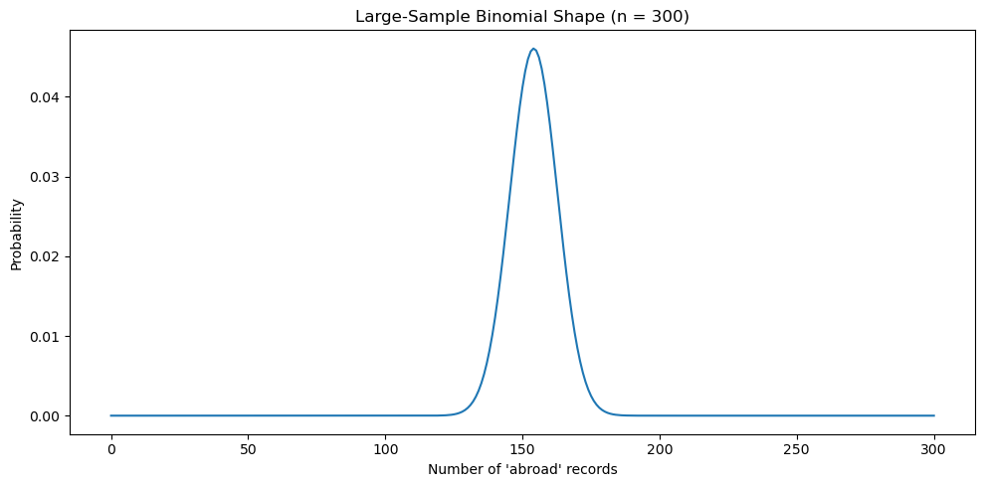
Figure A1. Large-sample Binomial shape with n = 300. Source: executed notebook output.
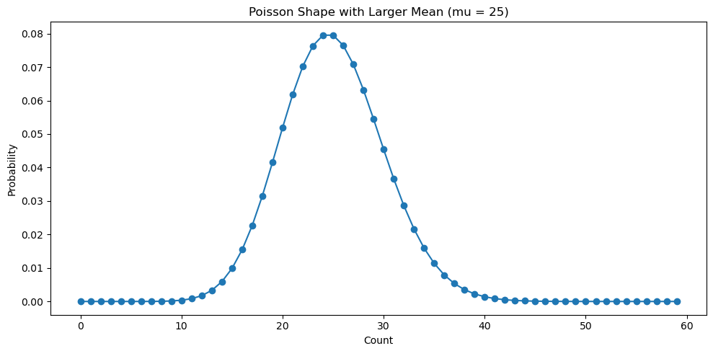
Figure A2. Poisson shape with a larger mean, mu = 25. Source: executed notebook output.

References
Environmental Protection Agency (EPA) 2026, EPA Licensee Waste Data. Available at: https://www.epa.ie/our-services/monitoring--assessment/waste/national-waste-statistics/waste-statistics-data-archive/epa-licensee-waste-data/
Environmental Protection Agency (EPA) 2026, Circular Economy and Waste Statistics. Available at: https://www.epa.ie/our-services/monitoring--assessment/waste/national-waste-statistics/
Eurostat 2026, Municipal waste by waste management operations (env_wasmun). Available at: https://ec.europa.eu/eurostat/databrowser/product/page/ENV_WASMUN
Eurostat 2026, Recycling rate of municipal waste (cei_wm011). Available at: https://ec.europa.eu/eurostat/databrowser/product/page/CEI_WM011
IBM 2026, IBM SPSS Modeler CRISP-DM Guide. Available at: https://www.ibm.com/docs/it/SS3RA7_18.3.0/pdf/ModelerCRISPDM.pdf
scikit-learn developers 2026, DecisionTreeRegressor documentation. Available at: https://scikit-learn.org/stable/modules/generated/sklearn.tree.DecisionTreeRegressor.html
scikit-learn developers 2026, RandomForestRegressor documentation. Available at: https://scikit-learn.org/stable/modules/generated/sklearn.ensemble.RandomForestRegressor.html
scikit-learn developers 2026, GridSearchCV documentation. Available at: https://scikit-learn.org/stable/modules/generated/sklearn.model_selection.GridSearchCV.html
Tufte, E.R. 2001, The Visual Display of Quantitative Information. Available at: https://www.edwardtufte.com/book/the-visual-display-of-quantitative-information/

